Dis-Afr-Namibia-Brandberg Inselberg-Hafted Biface Axe-200,000 BP

**Formal Label:** Namibia-Brandberg Inselberg-Hafted Biface Axe-200,000 BP

**Accession Number:**

**LC Classification:** GN865 N35

**Date or Time Horizon:** 200,000 BP

**Geographical Area:** Namibia-Brandberg Inselberg North

Map:

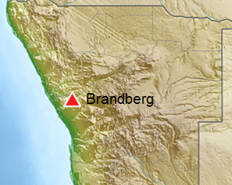 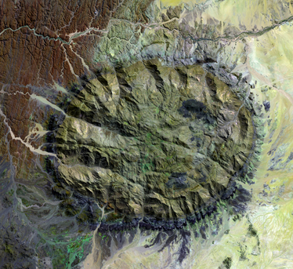

**Fig. 1,** location of Brandberg in Namibia; https://upload.wikimedia.org/wikipedia/commons/thumb/f/fa/Namibia_relief_location_map.jpg/390px-Namibia_relief_location_map.jpg

Fig. 2. Satellite view of Brandberg courtesy NASA; https://upload.wikimedia.org/wikipedia/commons/5/5a/Brand_hires_trimmed.jpg

**Cultural Affiliation:** *Homo erectus*

**Medium:** Non-local purple silicified sandstone matrix with cram colored inclusions.

**Dimensions:   
Weight:**

**Provenance: Susan Murcott, 2004.**

**Condition:** Tip of point broken off.

**Discussion:** This unique biface with prominent side notches allowed it to be hafted like a halberd providing a powerful fulcrum force. It was made by an early Hominin, probably by *Homo erectus*, even though all known *Homo erectus* excavated sites are east of Namibia, because this species is known for its fine tool work and aesthetic principles. The material from which this finely crafted biface was made is an attestation to the aesthetic acumen of the hunter of large game. It is fashioned from a beautiful purple silicified sandstone with cream inclusions, a stone that is not found in the Brandberg area. Thus, it must have been carried in from whereabouts presently unknown--a hardy task for one who has a dangerous purpose in mind. 200,000 years ago marked a wetter period when sub-Saharan Africa’s savannahs could support impressive megafauna such as the extinct rhinoceros. In order to hunt such beasts this silicified sandstone was selected for its extreme hardness (8 on Moh’s scale) as well as for its intrinsic beauty (as noted above). This Hominin hunter was cognitively selective about his hunting weapons and cognitively expert in his ability to craft such a weapon from it. The tip of this weapon has been broken off. To exert such a pressure on such a hard stone the object that was contacted with it must have been massive and hard too. The full story must remain hidden within the rock but just seeing a rhino offers many exciting clues, and the Black Rhino still roams in the bush near the campsites today!

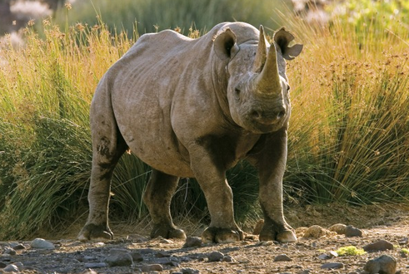 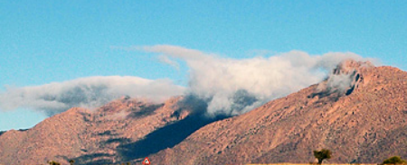

Fig. 3. One of Brandberg’s current residents, an African Black Rhino in the bush near the Ugab River. The current biface may have been used to hunt this rhino’s Pleistocene forebear. Courtesy Brandberg Rest Camp in Uis, an old mining town near Brandberg. <http://www.brandbergrestcamp.com/blog/wp-content/uploads/2011/11/Black-Rhino-400x300.jpg>

Fig. 4 The upper reaches of Brandberg captures the easterly winds with moisture laden clouds from the Atlantic Ocean. After http://media.ellerstrand.se/2012/07/Brandberg03.jpg.

Namibia’s Brandberg (2 573m/8 441ft) stands as a granitic pluton that was ejected through the earth’s mantle (Fig 2) to ascend as a wall to the westerly winds blowing in from the Atlantic Ocean which carries with them moisture–laden air (Fig. 4). Over millennia these moisture laden fissures in the granite would heat and expand during the day and then calve huge, house-sized granite blocks from the mountain. Higher on the Inselberg this moisture seeped into pools so that animals and people could survive up here when desertification ensued in the savannah below. To reach this high oasis above, these huge blocks form a frontier that requires friction climbing for animals and people alike. Above, among the pools of water are blocky caves in which ancient San Bushmen painted pictographs that documented their lives and customs in this oasis that was used in all of the periods of sub-Saharan desertification in the area.

Below the Brandberg plateau, in the Ga'aseb and Ugab River Valleys surrounding the northern face of the Inselberg is a zone where larger animal,s unable to escape desertification by ascending the mountain to the plateau, have perennially congregated. This is the zone of the large-game hunters, and this is where one finds huge surface scatters of stone flakes and some finished tools and weapons. Today Desert Elephants and Black Rhinos are constrained to this ecotone and still roam undisturbed in the bush along the banks of these River Valleys as their megafaunal ancestors did in the Pleistocene.

**References:**

Lenssen-Erz, Tilman. 2000. *Brandberg: der Bilderberg Namibias : Kunst und Geschichte einer Urlandschaft / Tilman Lenssen-Erz und Marie-Theres Erz ; herausgegeben und mit einem Vorwort von Gerhard Bosinski ; Geleitwort von Paul Bahn*. Stuttgart: Thorbecke.